Zepto Sales – SQL Queries

- Total Revenue by City
Purpose: Identify which cities generate the most revenue.
SQL :
SELECT City, SUM(`Total Revenue`) AS TotalCityRevenue
FROM zepto_sales_dataset_csv
GROUP BY City
ORDER BY TotalCityRevenue DESC;
OUTPUT:
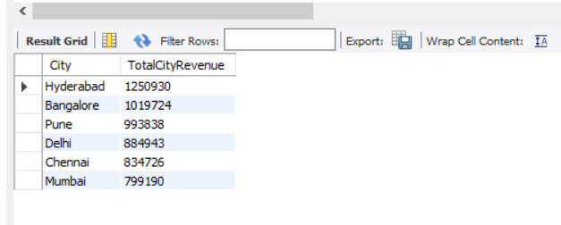

- Average Discount by Category
Purpose: See which product categories offer the highest average discounts.
SQL:
SELECT Category, AVG(Discount) AS AvgDiscount
FROM zepto_sales_dataset_csv
GROUP BY Category
ORDER BY AvgDiscount DESC;
OUTPUT:
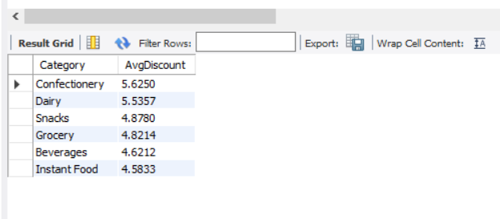

- Revenue Comparison: Influencer vs Non-Influencer
Purpose: Measure the impact of influencer marketing on sales.
SQL:
SELECT `Influencer Active`, SUM(`Total Revenue`) AS Revenue
FROM zepto_sales_dataset_csv
GROUP BY `Influencer Active`;
OUTPUT:
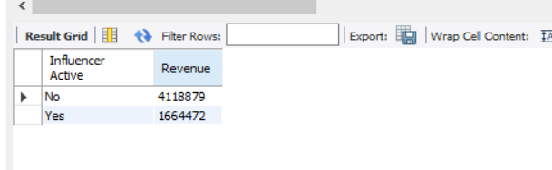

- Top 5 Products by Total Orders
Purpose: Highlight the most popular products by order volume.
SQL:
SELECT `Product Name`, SUM(Orders) AS TotalOrders
FROM zepto_sales_dataset_csv
GROUP BY `Product Name`
ORDER BY TotalOrders DESC
LIMIT 5;
OUTPUT:
